#11#
#11#
Keywords: keyword 1; …; keyword N
#11#

Name SURNAME, Name SURNAME*, Name SURNAME – bold text
#11#
#11#
TITLE OF THE ARTICLE IN ENGLISH – 13-POINTS, BOLD TEXT, ALIGN TEXT LEFT, CAPITALIZED
#11#
Summary. Summary text in English. The text must be justified. The right and left spaces from the page margins are equal 0,75 cm. First-line indent of this paragraph: 0,5 cm. Title of summary should be bold. The summary should include information about scientific achievements of the article.
#11#
#11#
1. INTRODUCTION
#11#
Authors should carefully read this instruction, review procedure, editorial policy, license policy and when sending the article in the cover letter should write that agree with the provisions of instruction.
All co-authors will receive author's copies of the journal. The cover letter should include a postal address for sending a parcel. The cover letter should also include the corresponding author's mobile phone number for prompt communication.
Articles published in this journal should contain new original materials and information. Responsibility for use of photos and drawings in the sent materials of articles lays on authors.
Authors of publications in journal do not get honorarium and also agree with the publication of articles in the printing version of the journal and also in the internet - version.
Article submission is free of charges. Currently, the cost of publication of one article in the journal:
for a foreign business entity (universities, institutes) article processing charge (APC) is equal 400 EUR + VAT rate 0% reverse charge = 400 EUR;
for a foreign individual recipient (private person) article processing charge (APC) is equal 400 EUR + VAT rate 23% = 492 EUR gross.
Payment shall be subject only to articles, which positively passed the review process.
#11#
#11#
2. CHAPTER TITLE, BOLD TEXT, ALIGN TEXT LEFT, CAPITALIZED
#11#
Present instruction is an example of an article text. The article should be prepared in Word text editor. Wherever where no special indications, Times New Roman 11-points font is obligatory. Single line spacing. First-line indent of each paragraph: 0,75 cm. Symbols #11# determine blank lines of a given height, but are not used in the article manuscript.
The article should include from 8 to 14 pages of text together with figures, tables and literature. An even number of pages is preferred. Article length restrictions are mandatory, but in the case of large volumes of information, the article may be divided into separate parts as separate journal articles.
Basic text may be written in English.
Document formatting: A4 Document, all margins: 2,5 cm.
Headlines. For the first page as it is shown in the example, but the number of journal, the volume, issue and the years of publishing will be specified by publisher. On the left of even pages – page number, on the right – authors (in the format: Name Initials. Surname, etc.). On the left of odd pages – title of the article (shortened version allowed), on the right – page number. For present instruction page numbering is exemplary. Final numbering will be specified by publisher.
Decimal numbering should be used for the paragraph’s titles, figures, equations and tables, as well as literature positions. Continuous numbering. Placing in the text of an article appropriate references to the bibliographic positions presented at the end is advisable. Literature references should be specified in square brackets, e.g. [2, 8-10].
The text of an article should be divided onto chapters and subsections –2 space lines 11 pt. before each chapter, 1 space line 11 pt. after each chapter; subsection titles – 1 space line 11 pt. before each subsection, after each subsection 1 space line 11 pt.
It is advised to use chapter numbering (1., 2.) and subsections as two-levels, i. e. 1.1., 1.2., 2.1., etc.
Every article must contain conclusion or summary at the end and literature list afterwards.
The article is ended with the sentence containing the date of receiving the text to the publisher and the date of revised form acceptation. The concreted dates will be written by publisher.
Publisher may insert separate departure from the advised rules (e.g. other than advised spaces between title and the text) in case of publishing need. The same might be applied to authors, but it should earlier be consulted with the publisher.
Text of the article and cover letter should be sent to: TransportProblems@polsl.pl or Aleksander.Sladkowski@polsl.pl. In case of any additional doubts please contact directly Aleksander.Sladkowski@polsl.pl.
#11#
2.1. Subsection title, bold text
#11#
For building equations Microsoft Equation Editor is being used. Basic font: Times New Roman, 12 pt, italic formatting. Number of equation with a straight font. Example of an equation:
(1)
#11#
#11#
3. TABLES, FIGURES
#11#
Every table should have it’s own title. Horizontal test direction is preferred. Using vertical text direction will be acceptable exceptionally for large tables. In this case the table will be positioned on a separate page.
Tables and figures numbering must me continuous and one-level.
An example of table building is shown below for Tab. 1.
Table 1
Values of critical gaps for small roundabouts
with one-lane minor roads and different value of exterior diameter

Exterior diameter [m] | below 24 | from 24 to 30 | above 30 to 36 | above 36
Critical gap [s] | 5.0 | 4.8 | 4.6 | 4.5
#11#
3.1. Graphics
#11#
Images’ graphic must be compatible with the Word program requirements. The quality of an image should be sufficient when it is readable.
The figure description in the text should be preceded with this figure and should be sufficient for its correct understanding. There should be titles placed under the figure.
Figure subtitle is in both languages below. Font: 10 pt., align text left, single space lines.
An example of figure and its subtitles are shown in Fig. 3.
The figures may also be presented in several parts, i.e. a, b, c… In this case, all the parts must be inserted on the same page and have one subtitle with explanation according to individual pat of the picture.
#11#
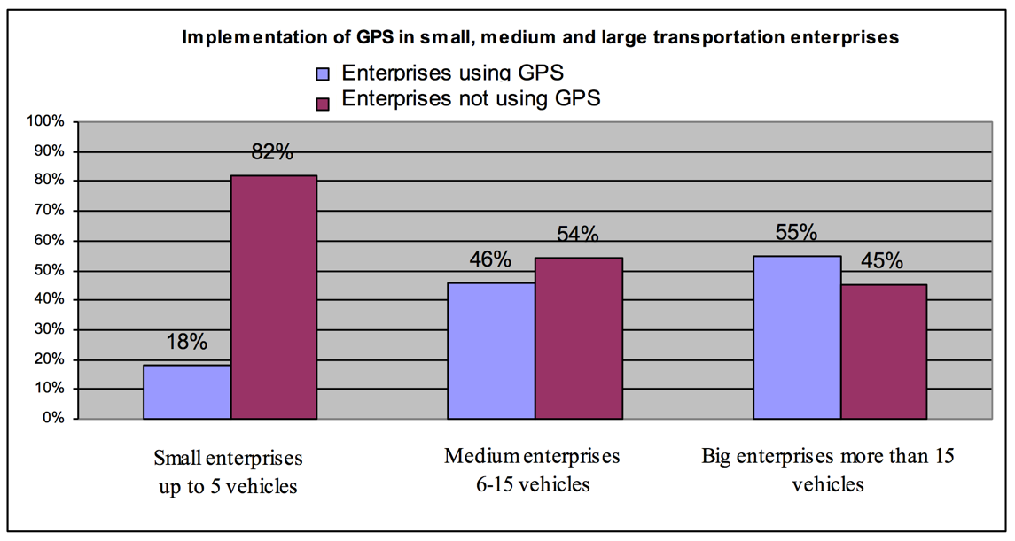
Fig. 3. Implementation of GPS in small, medium and large transportation enterprises
#11#
#11#
4. PAYMENT CONDITIONS
#11#
There are two options:
1. Personal payment to the account of the Silesian University of Technology.
2. Company payment (universities, institutes, companies). Perhaps invoicing by the editorial board. In this case, the editorial board should have the name of the company (in English), address and tax identification number, as well as fax number or e-mail for sending the scan.

Payment account:

Bank: ING Bank Śląski S.A. O Gliwice
Bank address: Sokolska 34, 40-086, Katowice, Poland
IBAN: PL 68 1050 1230 1000 0023 6055 5748
SWIFT: INGB PL PW
Account owner: Silesian University of Technology
Owner address: Akademicka 2A, 44-100 Gliwice, Poland
Always specify the purpose of the payment: „Article TP - name and surname of the first author”.
#11#
#11#
4. LITERATURE LIST
#11#
An example of preparing a literature list is shown below:
#11#
References
#11#
Examples of references to books, series and reports:

- Teply, S. & Allingham, D.I. & Richardson, D.B. & Stephenson, B.W. Canadian Capacity Guide for Signalized Intersections. Third Edition. Washington: Institute of Transportation Engineers. 2008. 230 p.
- Lupiyoadi, R. & Hamdani, A. Manajemen Pemasaran Jasa. Second Edition. Jakarta: Salemba Empat. 2006. XVIII, 298 p. ISBN: 979-691-36. [In Indonesian: Marketing Services Management].

Examples of references to journal articles:

- Sultanbek, M. & Adilova, N. & Sładkowski, A. et al. Forecasting the demand for railway freight transportation in Kazakhstan: a case study. Transportation Research Interdisciplinary Perspectives. 2024. Vol. 23. No. 101028. ISSN: 2590-1982. DOI: 10.1016/j.trip.2024.101028.
- Nees, M.A. & Herwig, K. & Quigley, L. et al. Relationships among driving styles, desire for control, illusion of control, and self-reported driving behaviors. Traffic Injury Prevention. 2021. Vol. 22(5). P. 372-377. ISSN: 1538-9588. DOI: 10.1080/15389588.2021.1909728.
- Могила, І.А. & Білоус, А.Б. & Крамажевський, Я.Р. Прогнозування інтенсивності руху з використанням часових рядів. Вісник Донецької академії автомобільного транспорту. 2011. No. 3. P. 15-25. [In Ukrainian: Mogyla, I.A. & Bilous, A.B. & Kramazhevs'kyj, J.R. Prediction of traffic using the time series. Bulletin of Donetsk Academy of Automotive Transport].
- Sutandi, A.C. Pentingnya transportasi umum untuk kepentingan publik. Jurnal Administrasi. 2015. Vol. 12. No. 1. P. 19-34. [In Indonesian: The importance of public transportation for public interest. Journal of Administration].
- Bichajło, L. Obserwacja drogi i związane z nią stany uwagi wzrokowej kierowców. Zeszyty Naukowe Politechniki Rzeszowskiej. Budownictwo i Inżynieria Środowiska. 2012. Vol. 59 (3/12/IV). P. 151-158. [In Polish: Visual road observation and assotiated visual attention modes. Scientific Papers of the Rzeszów University of Technology. Construction and Environmental Engineering].

Examples of references to papers in conference proceedings, digest, etc.:

- Černá, A. Optimalizace regionální autobusové dopravy. In: Proceedings of International Conference "Transportation Science". Praha: Fakulta Dopravní ČVUT. 2001. P. 70-75. [In Czech: Optimization of regional bus transport].
- Budzyński, A. & Sładkowski, A. Machine learning in road freight transport management. In: Using Artificial Intelligence to Solve Transportation Problems. Studies in Systems, Decision and Control. Cham: Springer Nature Switzerland. 2024. P. 485-565. ISBN: 978-3-031-69487-5. DOI: 10.1007/978-3-031-69487-5_9.

Examples of references to theses:

- Славич, В.П. Методи і моделі системи автоматизованого управління транспортними потоками міста. PhD thesis. Херсон: ХНТУ. 2009. 193 p. [In Ukrainian: Slavych, V.P. Methods and Models of Computer-Aided Management of Traffic Flows. PhD thesis. Herson: HNTU].

Examples of references to standards:

- PN-EN 13001-2:2013. Bezpieczeństwo dźwignic. Ogólne zasady projektowania. Część 2: Obciążenia. Warszawa: Polski Komitet Normalizacyjny. 57 p. [In Polish: Security of Cranes. General Principles for Design. Part 2: Loads. Warsaw: Polish Committee of Standardization].

Examples of references to patents:

- EP 1713073 A1. Universal Housing for Holding Storage Devices. Quantum Corporation, San Jose, US. (Thorson, T.A.) Publ. 18.10.2006. 17 p.

Examples of references to electronic materials:

- Annual Statistical Collection of the Republic of Uzbekistan 2013-2022. Tashkent. Statistics Agency under the President of the Republic of Uzbekistan. 2023. Available at: https://stat.uz/uz/nashrlar.
- Romania in figures 2011. Bucharest: National Institute of Statistics. 2011. Available at: http://www.insse.ro/cms/files/publicatii/Romania%20in%20figures_2011.pdf.
- Programming Resources - Phidgets Support. Available at: http://www.phidgets.com/docs/Programming_Resources
- Analiza danych o wypadkach drogowych w Polsce w 2022 roku. Polskie Obserwatorium Bezpieczeństwa Ruchu Drogowego. Available at: https://obserwatoriumbrd.pl/analiza-danych-o-wypadkach-drogowych-w-polsce-w-2022-roku/. [In Polish: Analysis of data on road accidents in Poland in 2022. Polish Road Safety Observatory].
#11#
Additional comments:
1. Page numbers should be provided for each cited article. If the article has an individual number, write it down without indicating page numbers.
2. Information contained in ISSN, ISBN, DOI, etc. is not mandatory, since some publications do not have this information. However, if the article has a DOI number, it should be provided in the above format.
3. For Internet sources, the date of page viewing is not indicated, since this information is not essential. The year of such publication is desirable information, but not mandatory, since it cannot always be found.
4. The titles of books, articles, journals and other sources should be given in the original language. In case of publication in languages other than English, the translation into English should be added in square brackets.
5. The basic principles of the design of the list of references and its citation are consistent with the standards ISO 690, PN-ISO 690 (Vancouver system).
6. Only publicly available sources of information are given in the final list of references. If the source of information is the internal documentation of any organization, this should be indicated in the text of the article.
#11#
#11#
Received XX.XX.20XX; accepted in revised form XX.XX.20XX

Organization of Author No. 1; exact postal address in English; e-mail: X@X.XX; orcid.org/XXXX-XXXX-XXXX-XXXX
Organization of Author No. 2; exact postal address in English; e-mail: Y@Y.YY; orcid.org/YYYY-YYYY-YYYY-YYYY
Organization of Author No. 3; exact postal address in English; e-mail: Z@Z.ZZ; orcid.org/ZZZZ-ZZZZ-ZZZZ-ZZZZ … (the number of authors is not limited, but we note that articles with a large number of authors go through the peer review process with difficulty; footnote text size 10) * Corresponding author. E-mail: mail@author.co (only one Author-correspondent)

